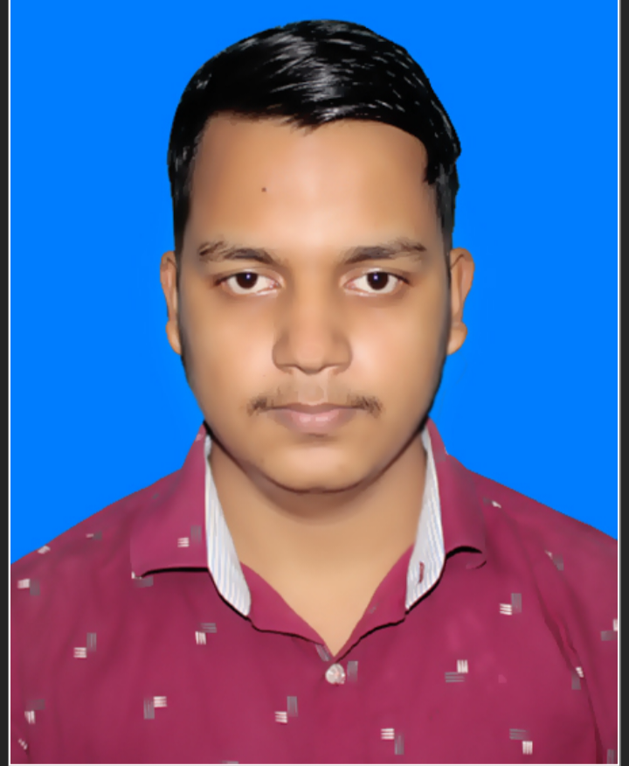 |  |  |  | Tanvir Bin Faruk Ramim

Experience
01-01-2023 to 31-05-23
Trainer • Assistant Trainer • Baraitali Computer Education Center
01-06-2023 to till now
Staff • Support Staff and Documentation • Reliance Technical Institute, Cox’s Bazar

Education
Diploma In Engineering
- University : Cox’sbazar Polytechnic Institute
- Year : 4th Semester Running
- Result : 3.38 out of 4.00 In 3rd Semester

Higher Secondary Certificate
- College : Satkania Government College
- Year : 2022
- Result :3.75 out of 5.00
Secondary School Certificate
- Institute :Baraitali High School
- Year :2020
- Result :4.28 out of 5.00

Skills
- I am Level-4 by Bangladesh Technical Education Board(BTEB) certified trainer on Web Design and Development
- I am Level-3 certified on IT Support and services from National Skills Development Authority(NSDA)
- Install and Use Operating System and Optimize Utilities
- Access Information Using Internet
- Maintain and Troubleshoot Personal Computer
- Carry Out Workplace Interaction in English
- Perform Basic Data Backup and Recovery
- Use Office Application Software
- Install and Configure Application and Utility Software
- Perform PC Assembling
- Interpret IT Support Service Fundamentals
- Perform Basic Networking
- Browsing Internet & Email
- Comfortable to google & their apps
- Using ChatGPT for problem solving
- Spoken English with basic Reading and Writing

Communication
- Strong Communication Skills
- Disciplined & Focused
- Session Management Skills (indoor & outdoor)
- Hard Working
- Specific goal oriented
- Teamwork
- Leadership
- Ability to work under pressure

Leadership
I am capable to lead a group of People and strong leadership skills. Effectively communicated vision, goals, and objectives to stakeholders and team members. Facilitated productive discussions and consensus-building among diverse groups. Provided guidance and motivation to team members

Career Objectives
Willing to build up career in a challenging position and to prove myself as a quick learner and highly energetic person to face any challenge on the field of relevant subject where the contribution will be acknowledged, if would be given an opportunity

References

Cox’s Bazar
Cox’s Bazar Sadar, 4700
 |  | +8801889421708
 |  | inboxtotanvirbinfarukramim.com
Ridoanul Hakim Riad
Programme Manager
Action Aid Bangladesh
riad9681@gmail.com
+8801814890851

Nusrat Zarin Nupur
Project Coordinator
Gender Based Violence in Emergency
Mukti Cox’s Bazar
nusratzarin.eco@gmail.com
+8801823530453

